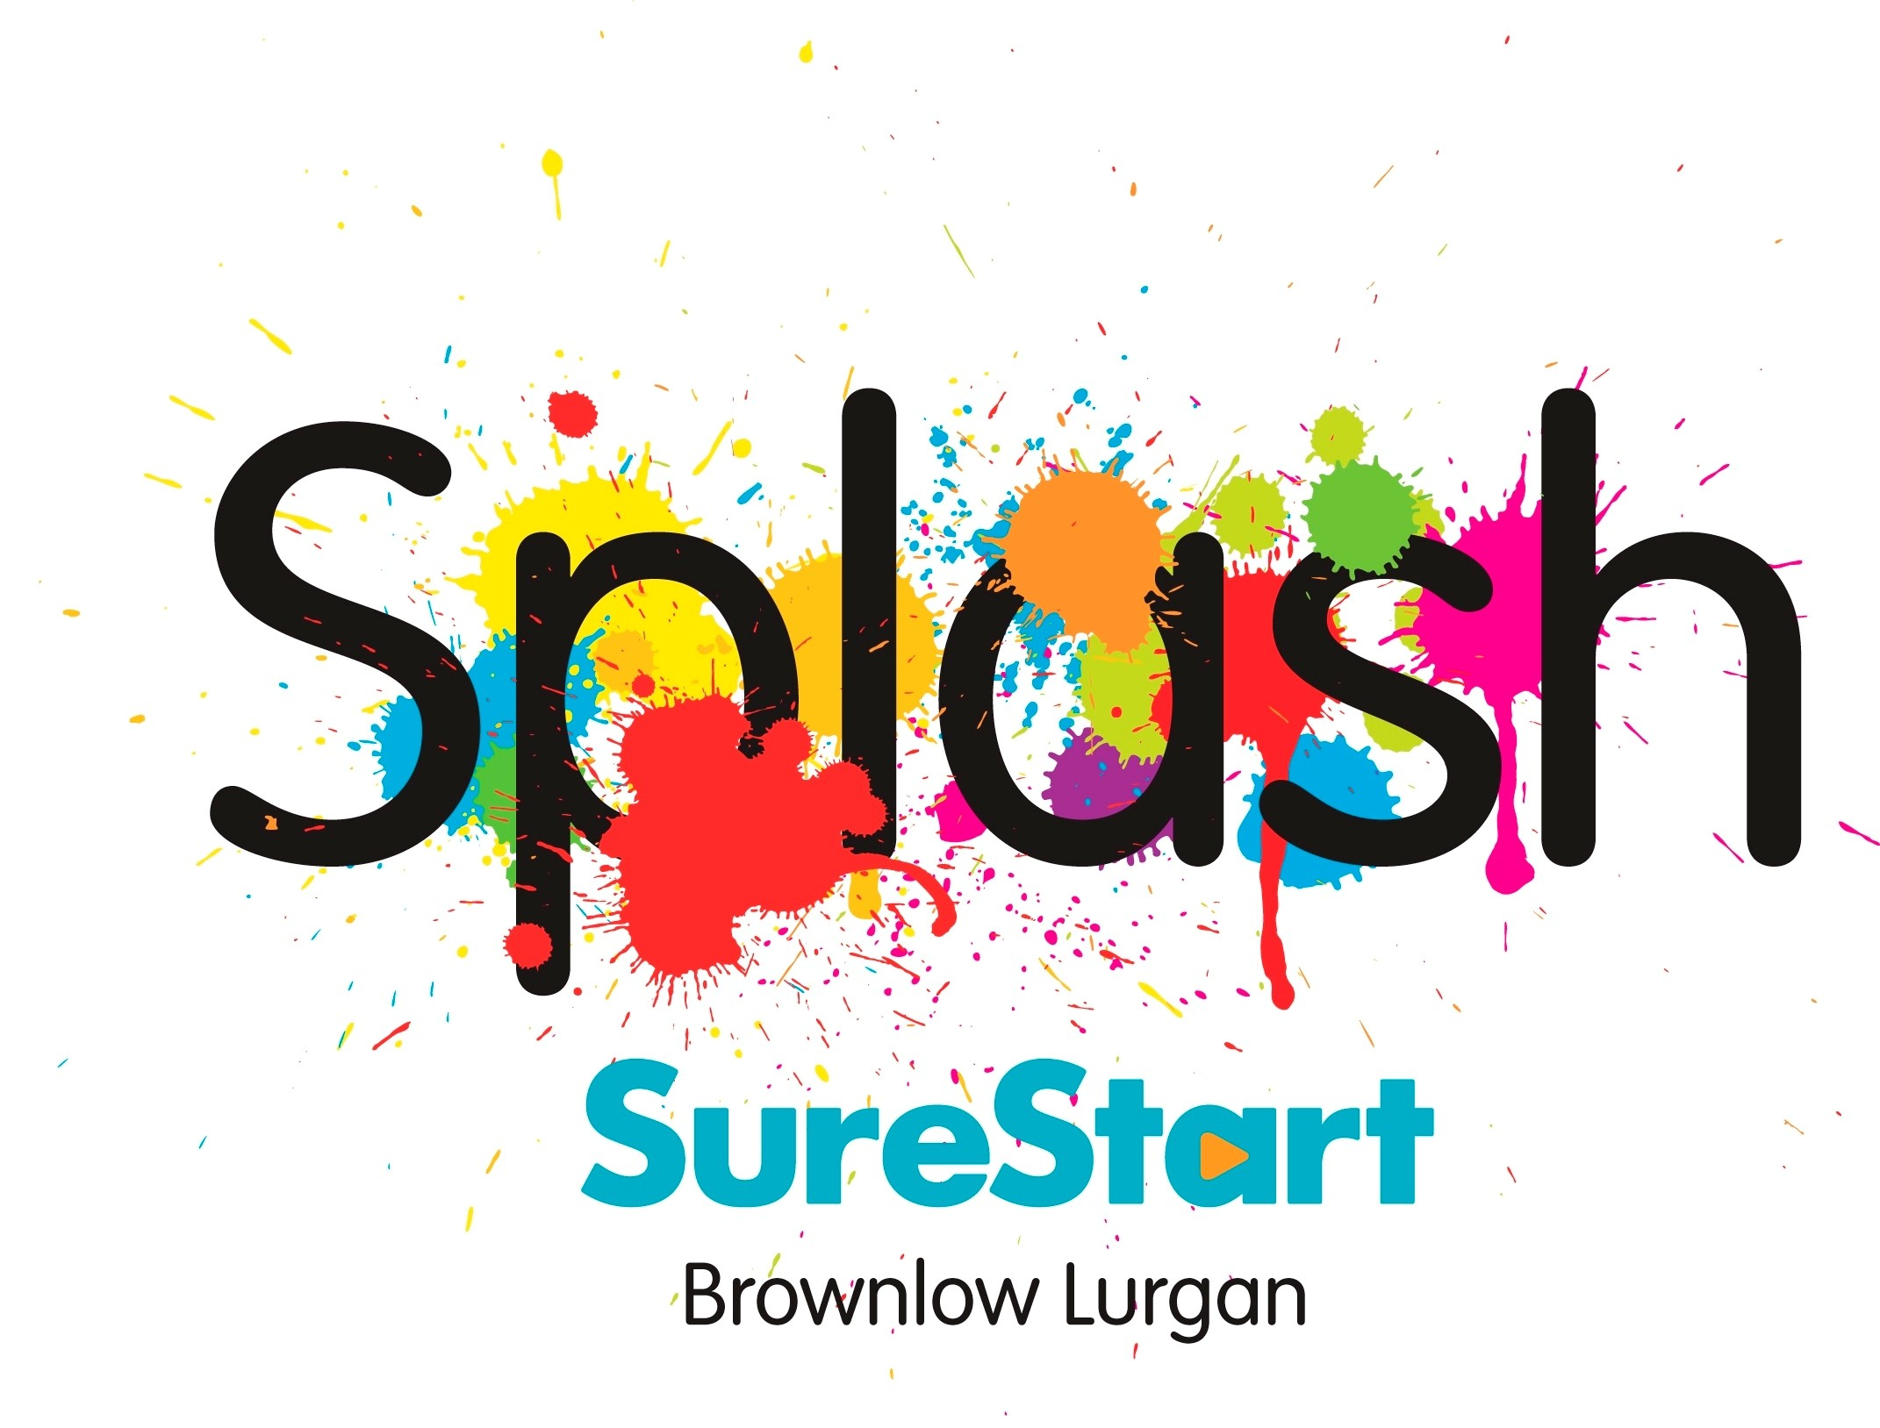

Forms of ID acceptable for The Developmental Programme For 2-3 Year Olds Expression of Interest.
The following proof of age and 2 proof of addresses will be required should you be offered a place
ESSENTIAL REQUIREMENT | 2 ITEMS FROM LIST BELOW
Original birth certificate issued at time of birth | Current UK Driving licence (full or provisional) including paper copy.  ALL THE DOCUMENTS BELOW MUST BE DATED WITHIN THE  LAST 3 MONTHS.
 | Utility Bill - electric, gas, landline
 | Benefit statement or letter - Income support, tax credits, job seekers employment & support allowance, housing benefit
 | Addressed payslip
 | Mortgage statement
 | P45/60 statement
 | Land and Property Services Agency rates demand
 | Doctor/hospital appointments for parent, child or siblings

Please note: Bank statements, mobile phone & directory bills WILL NOT be accepted

SPLASH SURESTART
Developmental Programme for 2-3 Year Olds
Expression of Interest Form

Splash SureStart
Office 1, First Floor,
Legahory Centre,
Craigavon BT65 5BE
028 38 313360
The Splash SureStart Developmental Programme for 2-3 Year Olds is one of a wide range of Programmes which Splash SureStart offers to families in your local area.

There are a limited number of places on the Programme. These will be offered to children and parents who can benefit most from participation in the Programme.

Submission of this Expression of Interest is not a guarantee of a place on the programme.

The Splash SureStart Developmental Programme for 2-3 Year Olds runs from September – June.

To be considered for the programme:
- Children must be a minimum of 2 years of age on 2nd July of the intake year.
- Children must live within the Splash SureStart area. Drumgor, Drumgask, Drumnamoe, Taghnevan, Church, Court, Woodville 1, Parkmore Estate and Mourneview.
- The Family must be registered with the SureStart Project prior to commencement of the
programme.
- Parents must commit to ensuring their child will attend on a regular basis (minimum of 80% attendance)
- Parents must agree to attend regular Stay and Play sessions (minimum 80% attendance) and accept home visits
NOTE: All information provided will be treated in the strictest of confidence. In accordance with the General Data Protection Regulation, Splash SureStart are obliged to ensure that your information is accurate and up to date. We may use the information provided on this form to update your family details currently held on our secure database.

Childs Details
Name | Date of Birth:  Male  Female |  | Languages Spoken
First Parent/Carer |  | Second Parent/Carer (if applicable)
Name  D.O.B. |  | Name  D.O.B.
Address  Post Code:  e-mail address: |  | Address  Post Code:  e-mail address:
Phone Numbers  Home  Mobile |  | Phone Numbers  Home  Mobile
Are you a single parent? Yes No

What do you hope you and your child will gain from taking part in this programme?

Does your child have a disability or developmental delay? If yes, is it

Queried Awaiting Diagnosis Has been Diagnosed

Details:

Do you have any concerns or worries about your child’s health or development? Please provide details if Yes.

Please tick if your child is supported by any of the following professionals:
- Consultant Paediatrician (Name and Contact Details_____________________________)
- Speech and Language Therapy (Name and Contact Details_____________________________)
- Behaviour Management (Name and Contact Details_____________________________)
- Health Visitor (Name and Contact Details_____________________________)
- Occupational Therapist (Name and Contact Details_____________________________)
- Social Worker (Name and Contact Details_____________________________)
- Physiotherapist (Name and Contact Details_____________________________)
- Dietician (Name and Contact Details_____________________________)
Other _______________ (Name and Contact Details_____________________________)

Do you give permission for us to discuss your child’s progress with the above-named professionals?
(insert a )
YES NO

Is your child known to Social Services? Yes No

If yes, which team? ________________________ Name of Social Worker ___________________

Information in relation to the IMMEDIATE Family

Does any family member living with the child have any Disability/Mental Health issues or addiction? Please provide details if Yes

Details of other children in the family:

Child 1: Name ____________________ Date of Birth_________________ Age _______________

Child 2: Name ____________________ Date of Birth_________________ Age _______________

Child 3: Name ____________________ Date of Birth_________________ Age _______________

Child 4: Name ____________________ Date of Birth_________________ Age _______________

Child 5: Name ____________________ Date of Birth_________________ Age _______________

Child 6: Name ____________________ Date of Birth_________________ Age _______________

VENUE: Please note only ONE venue can be applied for

Please indicate what programme you are applying for: -
Church of Nazarene AM - Wed, Thurs, Fri 9:30 – 12:00
Church of Nazarene PM - Mon, Tues, Wed, 13:30 – 16:00
Church of Nazarene MIXED - Mon & Tues 9:30 – 12, Thurs 13:30 – 16:00
The Hub - Mon, Tues, Wed - 13:45 – 16:15
Drumellan - Mon, Tues, Wed - 9:30 – 12:00

Supporting Statement (From SureStart Team Member or other relevant Professional.)
The programme is suited to all two-year olds but in particular those children whose development may be compromised by social, emotional, environmental or physical factors. Please note when completing this statement, the response needs to clearly demonstrate how the programme will meet the child’s needs. Please include as much information as possible in relation to the child’s development and how it may be compromised. For example, if a parent has a disability, the statement must reflect how this affects the child and how the programme can be used to support the child. Parents must co-sign all information provided.
NB: This section will not require completion by all families. A parent cannot complete this section.
Please use only one sheet. Parents must co-sign all information provided:
Supporting Statement
Name of person providing statement: | Job Title:
Address:  Post Code: | Phone Number:
Statement:

Signature of person providing Statement  Date | Signature of parent/carer  Date

Declaration by Parent/Carer (insert )
- I confirm that all information provided is accurate
- I confirm that my child will be 2 years of age on or before 2nd July of the intake year.
DOB between 02/07/19- 01/07/20
- I confirm that my child lives within the Ward areas covered Splash SureStart.
- I confirm that my family is registered with Splash SureStart.
- I confirm that I am prepared to participate in the programme by committing to attend Stay and Play and Workshop sessions and accept Home Visits to discuss my child’s progress.
- I confirm that I will ensure that my child has a minimum of 80% attendance on the programme
- I confirm that I will attend a minimum of 80% of the Stay and Play sessions.

Signed ____________________________Date __________________ (Parent/Carer)

Please ensure all contact details are included and correct.
It is important to include a valid email address where possible as this is our preferred method of contact.

Please note , if you do not receive an email confirming receipt of your Expression of Interest form within 5 working days, please email info@splashsurestart.org or call our office on 028 38 313360.

Please submit a copy of the completed Expression of Interest Form on or before Friday 15th April at 4.30pm to:

Splash SureStart
Office 1, First Floor
Legahory Centre
Craigavon
BT65 5BE

Late Expression of Interest Forms cannot be accepted

