IMPORTANT POINTS TO CONSIDER WHEN COMPLETING YOUR EXPRESSION OF INTEREST FORM:

- Expression of Interest Forms will be posted to eligible children registered with the project or downloaded from the Splash Surestart website.

- Please complete your Expression of Interest forms fully and remember to sign.

- As we can only assess each Expression of Interest on the information provided to us on the form, it is vital that you include as much relevant information as possible.

- Please provide a valid email address where possible. Ensure that all contact details are provided and accurate.

- All Expression of Interest forms must be returned no later than Friday 26th April at 4pm. Forms should be posted back into Splash SureStart (address on form).

- No forms will be considered after the closing date so please ensure you give yourself enough time to complete form.

- If you require any further information, please contact the Office on (028) 38313360 or info@splashsurestart.org

Please note:
Parents/ Carers will be notified via letter of the outcome of their application for the Developmental Programme 2 – 3 Year Old typically by the middle of June. Follow our social media channels or see our newsletters for the most recent updates.

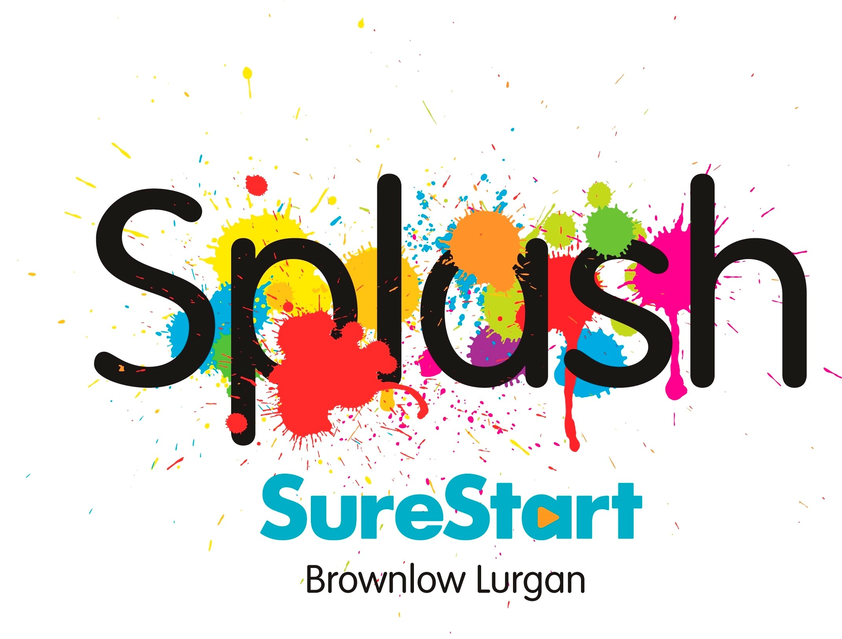

Splash SureStart Developmental
Programme for 2-3 Year Olds
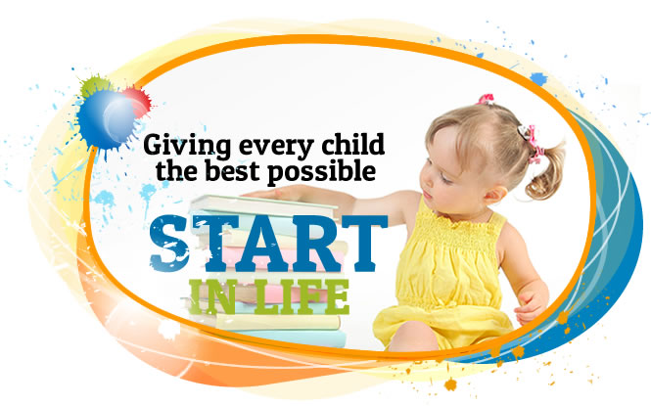

Supported by the Strategic Planning and Performance Group and
The Department of Education





The aim of the Developmental Programme for 2-3 Year Olds is to ‘focus on constructive play in group settings to enhance children’s social and emotional development, build on their communication skills and encourage imagination through play’.

WHO CAN APPLY?

- Eligible families must be registered with Splash SureStart.
- The child must live within the ward areas covered by Splash SureStart.
- Proof of Age/Residency will be requested on allocation of a place in the programme.
- Children applying must be born between:
02/07/21 – 01/07/22.

SPLASH SURESTART HAS 5 PROGRAMMES:

Venue | Days of week | Time
Church of Nazarene AM | Wed, Thurs & Fri | 9:30 –12:00
Church of Nazarene MIXED AM/PM | Mon, Tues  Thursday | 9:30 – 12:00  13:30 –16:00
The Hub PM | Mon, Tues & Wed | 13:30 – 16:00
St Peters AM  Sports and Recreational GAA/GAC Centre | Mon, Tues & Wed | 9:30 –12:00
St Peters PM  Sports and Recreational GAA/GAC Centre | Mon, Tues & Wed | 13:30 -16:00
PROGRAMME DETAILS:

- Each year the project receives more Expression of Interest forms than places available, therefore even if you are currently registered with Splash SureStart, this unfortunately does not automatically guarantee a child a place.
- The project will try to accommodate First Preference venue option, but unfortunately this cannot be guaranteed.
- Criteria is set regionally, and this criterion is used to allocate places. The criteria are confidential and is not shared with other individuals.
- Once settled, children will attend for a maximum of three 2.5-hour sessions per week; this may be reduced to meet children’s needs. The programme implements a Pathway of Care approach to support an individual child’s needs within the programme.
- Parents/Guardians are required to attend a 1 hour monthly Stay and Play session. If parents cannot attend, they are asked to arrange for another adult to attend with their child.
- The programme provides a daily healthy snack for children.
- We work with the wider multidisciplinary team e.g. Occupational and Speech Therapists, Health Visitor, Play and Family Support Team.
- Children should achieve 80% attendance of the programme.
- There is no charge to attend the programme.
- Unfortunately, no transport service is available.

PARTNERSHIP WTH PARENTS

Recognising that parents are the first and most important educators in children’s lives, we actively welcome and encourage parents’ contributions to the programme by:

- Giving verbal feedback on a daily basis, to include what your child did and played with, any incidents or accidents that may have occurred etc.
- Having an open-door policy so parents can come into the room at the start and end of each session.
- Stay and Play sessions are a fun event where the parents and children come together to share experiences/activities. These sessions enable staff to model and share good practice, promote parental involvement and enables children to share their experiences with their parent/carer.
- Home visits are a very important aspect of our programmes, and we normally complete 4 per year. Home Visits provide you with an opportunity to chat to staff about your child’s progress and about any worries or concerns you might have.

